|  |  |  |  |  |  |  |  |  |  |  |
| --- | --- | --- | --- | --- | --- | --- | --- | --- | --- | --- |
| |  | | --- | |  | |  | EarlyCatholicFamilyLife.org | |  | | --- | |  | |  | | ECFL_Logo_Final JPG (5) | |  |  |  |

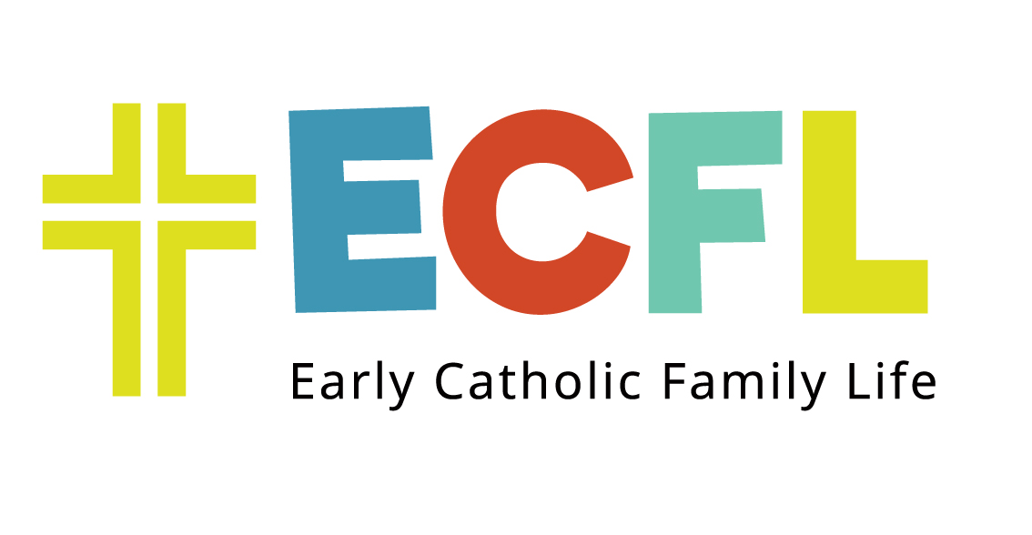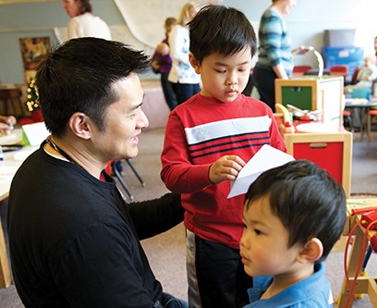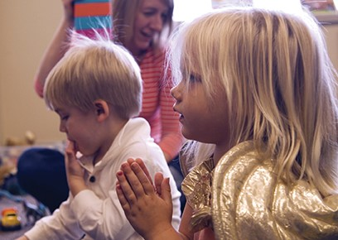

**BELIEVE** that you can bring Jesus’ peace and joy to your children every day!

**CONNECT** with like-minded parents in a welcoming environment!

**BELONG** to a community that supports you!

**LEARN** ways to teach the faith and create a Catholic culture in your home!

A child’s first and most important teachers are his or her parents. The mission of ECFL is to connect parents with their peers and empower them to raise their children in the Faith.

ECFL welcomes families with children 0-6 years old. Its sessions facilitate family interaction, parent peer-connection and education.

# ECFL at *#Parish Name#*

*Parish Specific Content*

For more information and to register please contact

**…..**



|  |  |  |  |  |  |  |
| --- | --- | --- | --- | --- | --- | --- |
|  |  |  |  |  |  |  |

# Early Catholic Family Life

Early Catholic Family Life (ECFL) is a program designed to draw parents and their children into faith community. We welcome young families and empower them to raise their children confidently with Jesus. We do this by connecting parents with their peers and helping them to learn the best practices in early childhood faith development. We believe that parents are a child’s first and most important teachers.

## Creating a Catholic Culture

ECFL helps parents to learn how they can give their children a Catholic worldview and the beginnings of a strong faith through their everyday witness of the faith in the home.  It is through this witness that they create a home with a Catholic Culture.

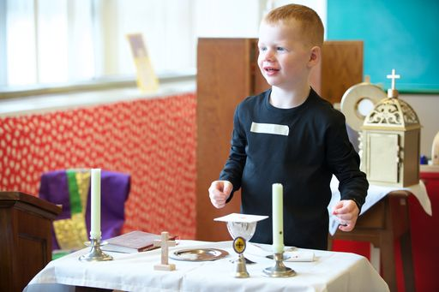

# What is the ECFL Program?

* ECFL is a parent-child program aimed at an underserved but essential part of all parishes – parents with children 0-5 years old.
* ECFL is an 8-session 2-hour class. Classes can be offered weekly, monthly, on week days, weekends or during evening hours. Each class includes early childhood, faith-based and fun activities for families.
* ECFL consists of a parent-child interaction component, a parent discussion time and a children’s time.
* ECFL gives parents an opportunity to learn more about their Catholic faith, discuss faith with other adults, and build supportive relationships within the parish.

##### *"I am walking away after each session not only with new information but most importantly that spiritual energy I most need to be a good mother."*

*ECFL Parent*

# Benefits to parents:

* Receive hands-on guidance in bringing the Catholic faith to their children
* Learn about their vocation, develop a vision for their family, are inspired to continue to grow in their own faith
* Build relationships with other parents, forming a Catholic community of parents for ongoing support and encouragement
* Deepen their relationship with the parish
* Consider Catholic education for their children